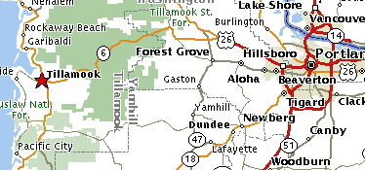
2004 NOHVCC National Conference Preride Info
Agenda: 9~9:30 each day
- Monday – Advanced Dirtbike Ride: Cedar Creek
- Tuesday – Dune Ride: Sand Lake
- Wednesday - All Ride: Jordan Creek
- Thursday - 4wd Ride: Brown’s Camp

